Milestone 3
Nowrin Mustary
Faculty of Computing & Data Sciences, Boston University
Module B: AI for Leaders
Dr. Joshua Von Korff
March 9, 2025

Abstract
This project analyzes real estate trends and investment opportunities using three key datasets: the USA Real Estate Dataset, the Austin, TX House Listings Dataset, and the Inside Airbnb Dataset. The USA dataset provides a broad market overview with over a million listings, while the Austin dataset focuses on 15,000 regional listings. The Inside Airbnb dataset offers insights into short-term rental properties, with over 75 variables on host details, amenities, pricing, and availability. Through exploratory data analysis (EDA), this project aims to identify undervalued properties, assess short-term rental profitability, and predict future property values based on factors like size, location, and historical trends.
Introduction:
Over the course of seven weeks, I conducted extensive coding and Exploratory Data Analysis (EDA) to clean and analyze the data, uncover trends, and generate meaningful insights. The first step involved summarizing the datasets using info() and describe() to understand their structure, data types, and key statistics. I checked for duplicate rows and inappropriate duplicate values in specific columns. I also examined missing or null values, particularly in the USA Real Estate Dataset, which contained a significant number of missing entries that required careful handling. Depending on the context, I either imputed missing values (e.g., using the mean or a relevant substitute) or removed incomplete records when necessary. Additionally, I identified and corrected inconsistent data, such as unrealistic values.
Insights from Data Preprocessing
The goal of preprocessing was to clean and prepare these datasets for further analysis, ensuring consistency, accuracy, and usability.
USA Real Estate Dataset
In this dataset, I found no fully duplicate rows, but there were duplicate values in the street column, showing data before and after a sale (e.g., address 78.0, 'Audubon', 'Iowa', 50025.0). And multiple properties can share the same street address.
A significant number of missing values were found, particularly in the "prev_sold_date" column, which I replaced with a boolean indicator. Other missing values in columns like bedrooms, bathrooms, acre_lot, and house_size were imputed with their respective mode values. Columns such as “street” and “brokered_by” were removed as they were not useful for numerical analysis. The "zip_code" column was converted to a string since zip codes represent categorical location identifiers.
The dataset exhibited class imbalance, with major cities like Houston, Chicago, and New York dominating the data, while smaller cities had very few entries.
The high volume of missing values and outliers suggested that further careful data imputation and robust statistical methods would be needed to avoid bias in predictive models.
Austin, TX House Listings Dataset
There were no fully duplicate rows or missing values. I corrected inconsistencies, such as "year_built" values beyond 2026, which isn’t possible. Several redundant columns, including zpid, streetAddress, homeImage, latestPriceSource, and numOfPhotos, were removed to streamline analysis, as they provided excessive detail unnecessary for EDA. The "homeType" column was one-hot encoded to handle multiple categories. The dataset exhibited a clear class imbalance, with Single Family homes dominating, while Condos, Townhouses, and MultiFamily listings were significantly underrepresented.
Inside Airbnb Dataset
While there were no fully duplicate rows, some duplicate values appeared in the license column. However, the id column was unique for each listing, so no rows needed to be deleted. The neighbourhood_group column had a significant number of missing values and was dropped, while missing values in reviews_per_month and price were filled with their median values. Any remaining rows with missing data were removed. The room_type column, which had four distinct categories, was encoded using one-hot encoding. The dataset exhibited extreme class imbalance, with Entire home/apt comprising 92.7% of listings, while categories like Hotel room and Shared room were significantly underrepresented, potentially impacting modeling results. After handling missing values, removing unnecessary columns, addressing duplicates, and encoding categorical variables, the dataset was significantly improved and ready for further analysis.
Univariate analysis
USA Real Estate Dataset
For the USA real estate dataset, the price and house size variables exhibited a wide range, necessitating log transformation. The histograms of log-transformed price and log-transformed house size displayed unimodal distributions with a sharp peak, suggesting a log-normal distribution.
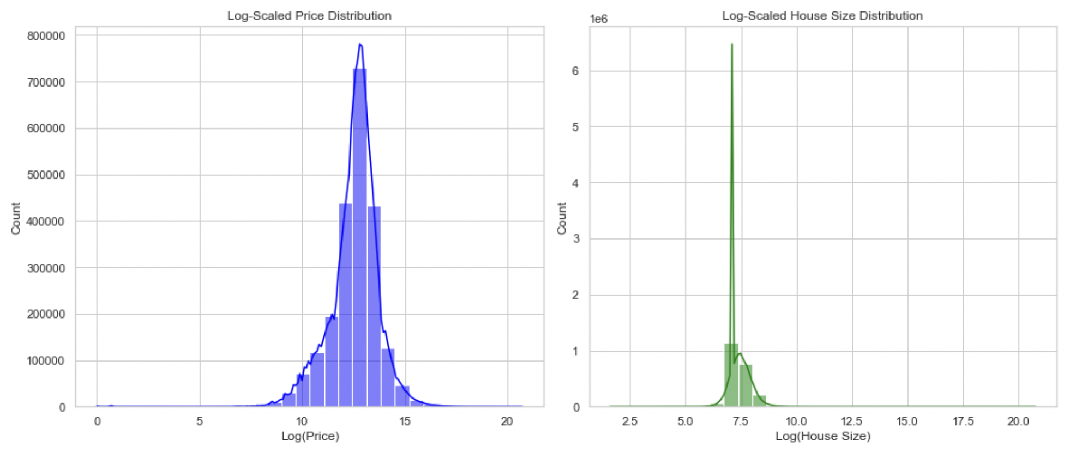
A bar plot was used to analyze the distribution of properties across different states. This visualization highlighted variations in the number of real estate listings per state, revealing regional differences in housing availability.
I used box plots to find outliers, and found out there are some outliers in price, bed and bath columns.
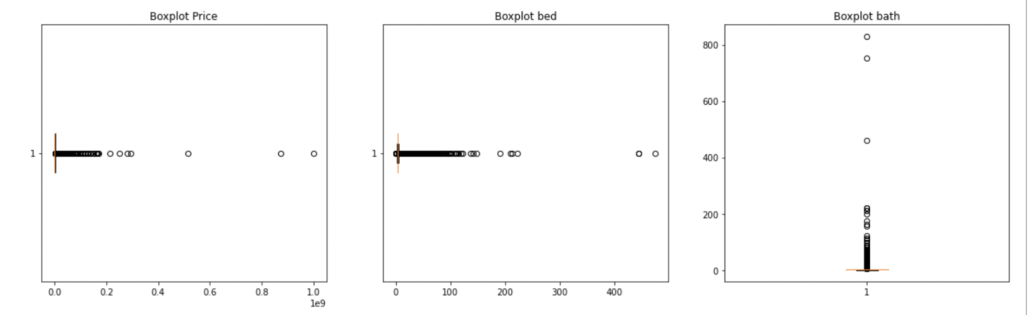
Austin, TX House Listings Dataset
Histograms of the Austin house listings dataset showed right-skewed distributions for numerical variables like price, number of bathrooms, living area square footage, and number of stories. Number of appliances, school ratings, and students per teacher had bimodal or multimodal distributions, indicating distinct groups. Features like the number of schools and community features had categorical-like distributions.
The KDE plot for property tax shows a sharp peak around 1.98–2, indicating that most properties fall within this tax range. The yearBuilt distribution highlights a significant increase in construction activity after the 1950s, with peaks in the 1980s and early 2000s. The "Number of Stories" column showed peaks at one, two, and three stories.
The bar plots indicate that while heating and cooling systems are common in most homes, features like a scenic view or spa are relatively rare. Violin plots reveal that the average school size falls between 1,000 and 1,500 students, with fewer very small or very large schools.
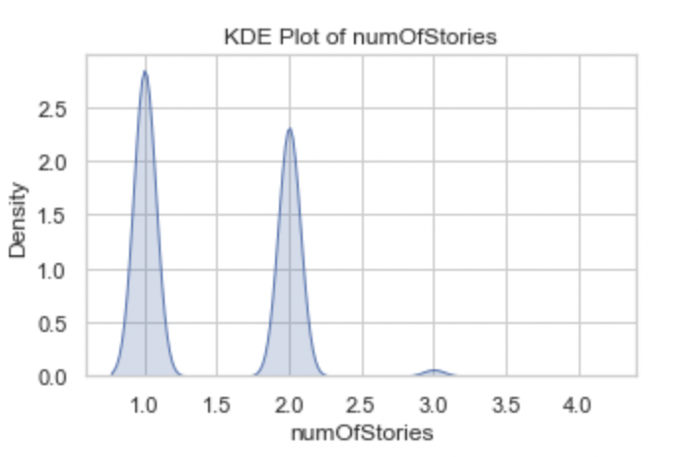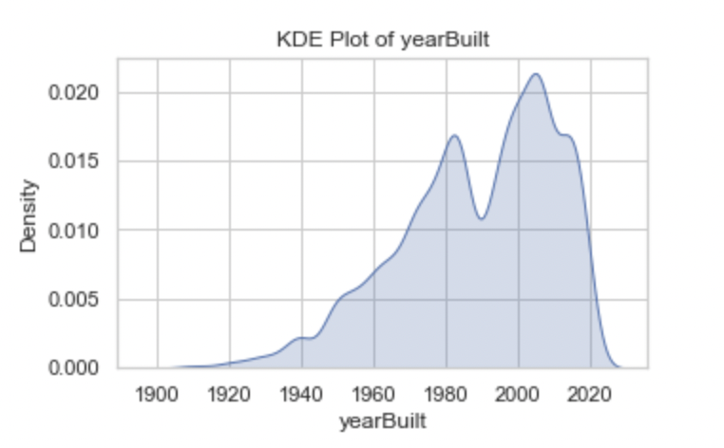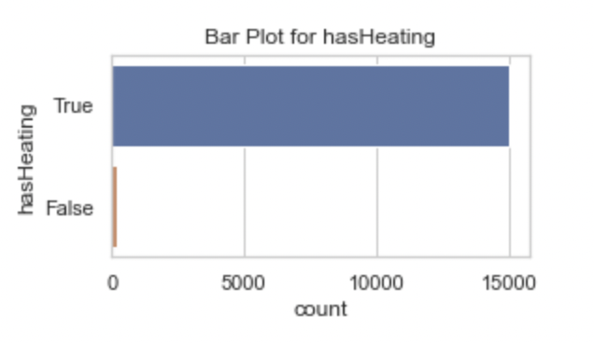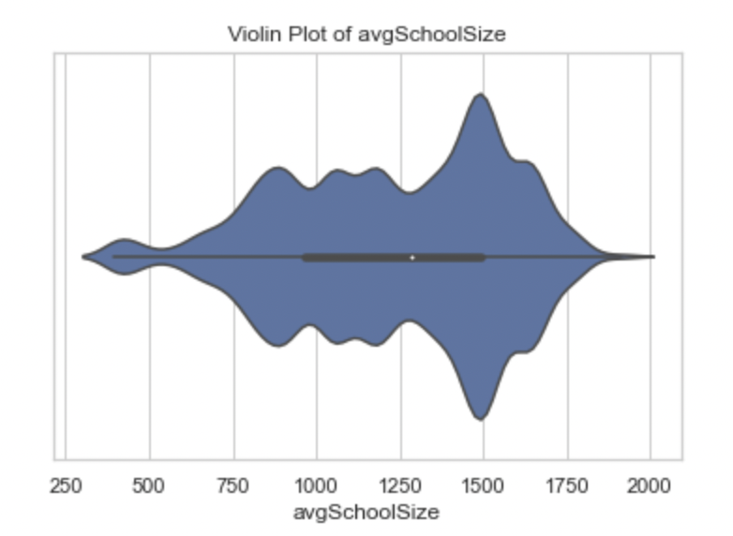
Airbnb Dataset
A bar plot of room type distribution revealed that entire homes/apartments were the most common listing type, followed by private rooms, while shared rooms and hotel rooms were significantly less frequent.
A box plot of price and minimum nights exposed extreme outliers, indicating that while most listings had reasonable prices and stay durations, some properties had exceptionally high values. These findings suggest that price distributions in Airbnb listings may be influenced by luxury accommodations and properties with extended minimum stay requirements.
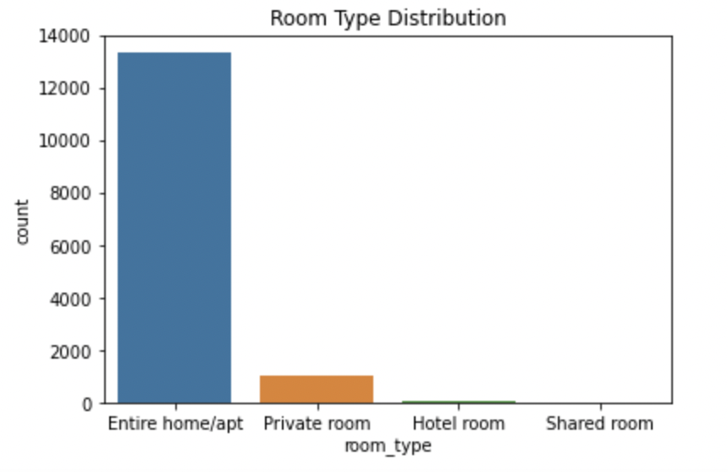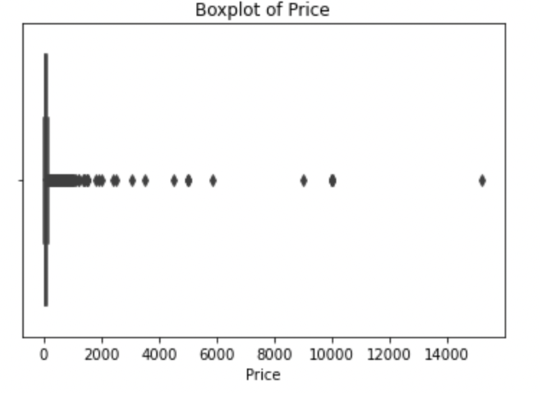
Bivariate Analysis
U.S. Real Estate Analysis
A violin plot was created with the logarithm of price against the property status. The results indicate that ready-to-build properties exhibit a more consistent price distribution, with fewer high-price outliers. In contrast, both sold and for-sale properties show greater price variability, suggesting that they encompass both affordable and high-end homes.
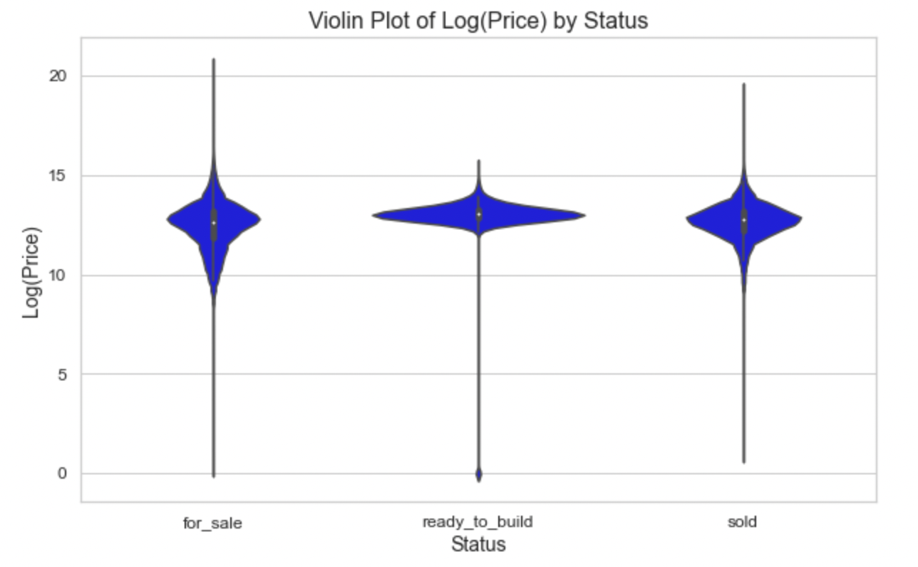
A correlation heatmap was also generated, revealing surprisingly weak correlations between price and features typically associated with real estate valuation, such as house size, the number of bedrooms, and the number of bathrooms. This weak relationship suggests potential data quality concerns.

Austin Housing dataset
A violin plot comparing price distributions across different home types revealed that vacant land and single-family homes have the most pronounced price variability, with long upper tails indicating the presence of extremely high-value properties.
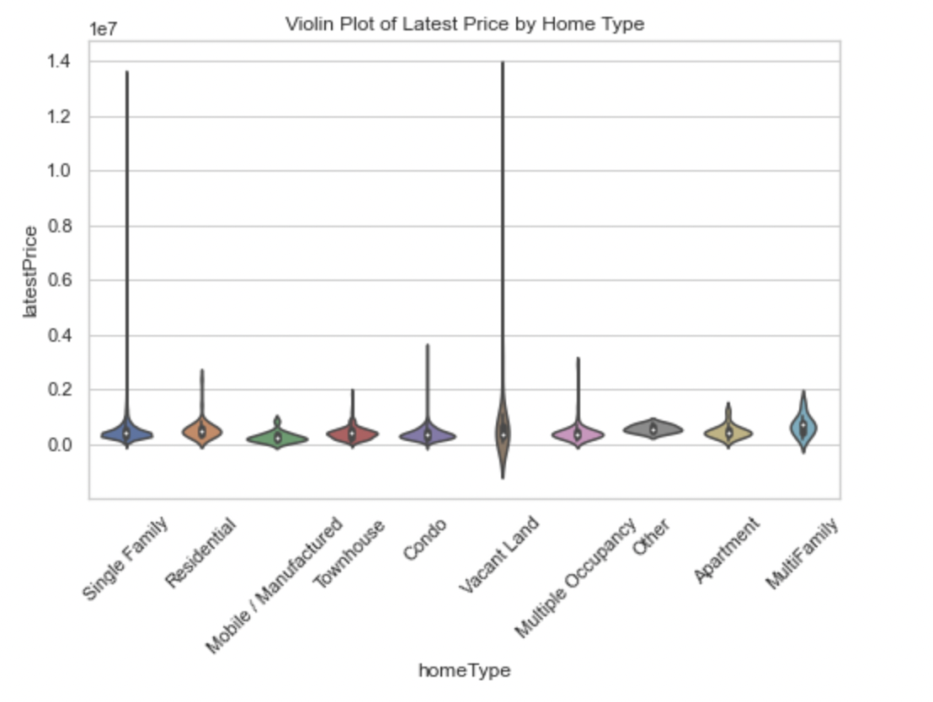
Grouped histograms for school-related features, such as the number of primary, middle, and high schools per zip code, showed a positive relationship between educational institution density and property values. Zip codes with more schools tended to have higher property prices, suggesting that school quality and proximity influence real estate prices.
A histogram of average prices by zip code revealed a skewed distribution, with prices increasing as zip code numbers rose, possibly reflecting the geographic layout of premium areas.
A scatter plot comparing lot size and living area square footage showed a positive correlation, confirming that larger plots typically have larger living spaces. The correlation heatmap for the Austin dataset also revealed moderately high correlations among various features.
Inside Airbnb Dataset
A scatter plot comparing reviews per month with the year of observation revealed that the number of reviews has increased over time, likely reflecting the rising popularity of Airbnb accommodations.
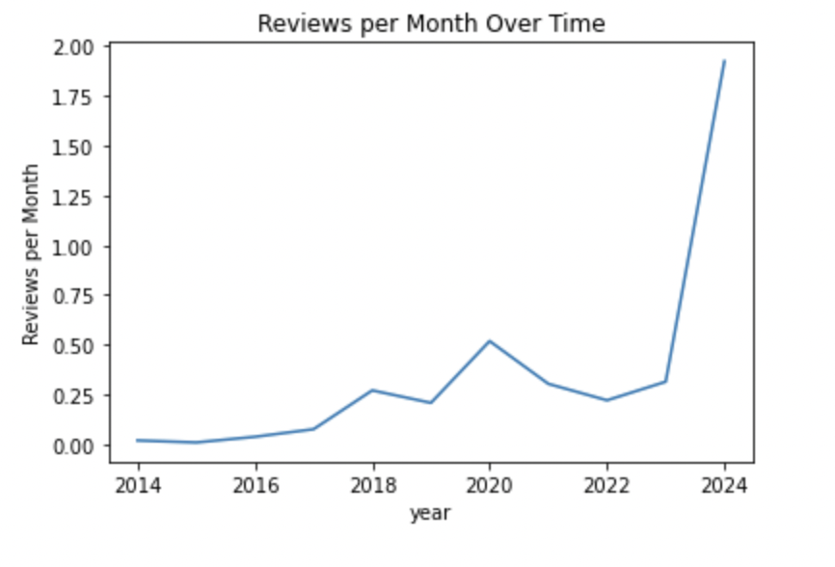
A pair plot of key variables, including price, reviews per month, and availability over 365 days, illustrated interesting trends. Price remained relatively stable except for a few outliers, regardless of variations in availability and reviews per month. This suggests that Airbnb pricing strategies may not be highly sensitive to these factors or that other determinants play a more significant role.
An analysis of average price by neighborhood demonstrated that certain neighborhoods exhibit significantly higher prices. Finally, the correlation heatmap for Airbnb data showed comparatively higher correlation among features than USA Real Estate dataset.
Conclusions About the Data
The analysis of the USA Real Estate, Austin, TX House Listings, and Inside Airbnb datasets uncovered key trends and anomalies through data preprocessing, univariate, and bivariate analysis. These insights can inform real estate investment, pricing strategies, and rental market decisions. The datasets also provide a strong foundation for building regression and machine learning models to assist stakeholders in making informed buying or renting choices.
Expected Findings
The histograms of house prices in both the USA Real Estate and Austin datasets showed right-skewed distributions, with most properties falling in mid-range prices and fewer luxury properties with high values. The Austin dataset also revealed a positive relationship between the density of educational institutions and property prices. As expected, the USA Real Estate Dataset was heavily skewed toward major cities like Houston, Chicago, and New York City, reflecting real-world population distributions and higher housing market activity in larger metropolitan areas.
Unexpected Findings
The correlation heatmap in the USA Real Estate Dataset showed a surprisingly weak relationship between property price and typical predictors like house size, number of bedrooms, and bathrooms. Additionally, despite variations in availability and reviews per month, Airbnb prices remained stable, suggesting that factors like location or host pricing strategies may play a larger role than expected.
Dataset Qualification and Disqualification
No datasets were disqualified, but the USA Real Estate Dataset was less useful compared to the Austin, TX House Listings and Inside Airbnb datasets. It provided broad context but lacked detail, had more null and duplicate values, and required significant data cleaning. The low correlation between features made it harder to work with.
Supervised and Unsupervised Analyses
Several supervised and unsupervised learning techniques can be used:
Supervised Learning:
Linear Regression can be applied to the Austin, TX dataset to predict property prices based on key attributes like bedrooms, bathrooms, square footage, and location. Decision Trees and K-Nearest Neighbors (KNN) can help assess price determinants and find comparable properties in the USA Real Estate Dataset. In the Inside Airbnb dataset, classification models like Random Forest can predict whether a listing belongs to a superhost or is instant bookable based on amenities and location.
Unsupervised Learning:
Clustering (K-Means, DBSCAN): Geospatial clustering on Airbnb and Austin listings data to identify property hotspots, neighborhood trends, and price segments. Topic Modeling (LDA, NLP-based Analysis) can be performed on the Airbnb dataset’s descriptions to extract key themes influencing rental desirability.
Addressing Industry Concerns and Dataset Creator Questions
For real estate investment and price prediction, linear regression models can predict property values, addressing concerns about valuation accuracy and investment potential. Logistic regression can assess market volatility and price fluctuations, helping investors time their purchases.
For short-term rental profitability (Inside Airbnb Dataset), supervised models can predict pricing and reservation demand based on features like amenities and location. Unsupervised clustering can identify high-demand neighborhoods, while NLP techniques on descriptions can highlight attributes that maximize revenue.
The USA Real Estate Dataset provides a broader context for Austin housing trends, helping to validate local findings. While these questions were not directly addressed in my analysis, the preprocessing and analysis suggest that further exploration can effectively address them in the future.

References
Get the Data. (n.d.). Insideairbnb.com. Retrieved November 24, 2024, from
https://insideairbnb.com/get-the-data/
Pierce, E. (2021). Austin housing prices. Kaggle.com; Kaggle. https://www.kaggle.com/datasets/ericpierce/austinhousingprices/data
Shahriar Sakib, A. (2023). USA Real Estate Dataset. Www.kaggle.com. https://www.kaggle.com/datasets/ahmedshahriarsakib/usa-real-estate-dataset/data

